|  |
| --- |
| Jerreh Janneh |

Humber College Institute of Technology & Advanced Learning Smartwatch 0NB

Status

/1 Hardware present?

/1 Title Page

/1 Declaration of Joint Authorship

/1 Proposal (500 words)

/1 Executive Summary

# Declaration of Joint Authorship

We, Baltej Bal, Jerreh Janneh, and Thomas Aziz affirm all work submitted whether it be our prototypes or documentation through our collaboration is our own words. Any words, coding examples, schematics texts or tables used will be referenced where applicable. Work will be achieved by dividing the workload as follows: Baltej will provide an ADS1050 Pulse (Broadcom). Jerreh will provide a TMP006 IR (Pi Zero W) and Thomas will provide an ADXL345 (Broadcom). In the integration effort, Baltej is the lead for further development of our mobile application, Thomas will head Hardware development, and Jerreh will be responsible for connecting the two via the Database.

# Proposal

Wearable technology is a term used to describe devices that can be worn and provide a variety of features with devices we currently used by utilizing IOT connections. They have become immensely popular in recent years with the number of connected devices reaching 526 million worldwide as of 2017 and 1.1 billion sales in 2022, a few companies have created dedicated health and fitness technologies however many are low budget watches with few sensors and few embrace the features that appeal to most consumers looking for an all-around fitness companion these features include a more diverse array of sensors such as heartbeat sensors, the objective to create a smartwatch that utilizes sensors in tandem with a heartrate sensor these being body temperature sensors and a pedometer. fitted with components we hope to provide an option that stands outs. To this date we’ve created a mobile application, designed SQL databases, created custom PCBs, learned the development methodology of agile and waterfall design, designed embedded systems this proposal outlines the components and design intention.

Intended project key components are as below

Development platforms:

TMP006 IR (Pi Zero W):

ADXL345 (Broadcom):

MCP3008 Pulse (Broadcom):

We will continue to develop skills by reconfiguring component PCB’s, networks, and embedded systems using these key components to compact the design so that we may get the completed device to be small enough to fit on a person’s wrist whilst house the system in an enclosure that complements.

Our project progress will be Overseen by, Humber College Institute of Technology & Advanced Learning Computer Engineering Technology Capstones, ideally an employer in a position to potentially hire once we graduate. They will also ideally attend the ICT Capstone Expo to see the outcome and be eligible to apply for NSERC funded extension projects. The company that oversees our progress will be a Canadian company with a minimum of 2 full-time employees and have generated revenue for a minimum of two years. The components used will be small enough to fit in an Electronics Parts kit which have the following dimensions :12 13/16" x 6" x 2 7/8" = 32.5cm x 15.25cm x 7.25cm. this allows the components to be carried every day with ease.

Keeping safety and Z462 in mind, these prototypes will be developed and tested in a specialized lab equipped with proper ventilation where all group members will use appropriate eyewear. the highest AC voltage that will be used is 16Vrms from a wall adapter from which +/- 15V or as high as 45 VDC can be obtained. The maximum power consumption will not exceed 20 Watts. To prevent liability and mitigate injury we will not leave our prototypes unattended while plugged in as well as keep voltage to safe levels. At our current stage, all sensor/effectors have been built tested and have received satisfactory approval form previous courses to continue to this phase. the development will span a total of 14 weeks each week covering a new phase each handing in a deliverable resulting in a presentation to potential investors

# Executive Summary

The market for wearable devices is catered to comfort and luxury, most wearables with the array of sensors needed to track health that still uses a heartbeat and temperature sensor aren’t as common. Creating a smartwatch that utilizes sensors such as heart rate, body temperature and a pedometer may provide an option that stands out. This project attempt to solve this problem by providing just that a wearable device that uses motion tracking temperature sensing and heart rate tracking to deliver the ultimate fitness experience. This report goes over the schematics, tests, firmware, guidelines, budget duty fees and taxes, scheduling and progress phases of the smartwatch project.

Contents

Declaration of Joint Authorship 3

Proposal 5

Executive Summary 7

List of Figures 11

1.0 Introduction 13

1.1 Scope and Requirements 13

2.0 Background 15

3.0 Methodology 17

3.1 Required Resources 17

3.1.1 Parts, Components, Materials 17

3.1.2 Manufacturing 17

3.1.3 Tools and Facilities 17

3.1.4 Shipping, duty, taxes 17

3.1.5 Time expenditure 17

3.2 Development Platform 17

3.2.1 Mobile Application 17

3.2.2 Image/firmware 18

3.2.3 Breadboard/Independent PCBs 18

3.2.4 Printed Circuit Board 21

3.2.5 Enclosure 21

3.3 Integration 22

3.3.1 Wireless Connectivity 22

3.3.2 Database Configuration 22

3.3.3 Security and Testing 22

4.0 Results and Discussions 23

5.0 Conclusions 25

6.0 References 27

7.0 Appendix 29

7.1 Firmware code 29

7.2 Application code 29

# List of Figures

Figure 7. By Android Studio - https://developer.android.com/studio/, CC BY-SA 4.0, https://commons.wikimedia.org/w/index.php?curid=74094999 18

Figure 1. Initial schematic. This work is a derivative of "http://fritzing.org/parts/" by Fritzing, used under CC:BY-SA 3.0. 19

Figure 2. This work is a derivative of "http://fritzing.org/parts/" by Fritzing, used under CC:BY-SA 3.0. 20

Figure 3. Breadboard prototype. 20

Figure 4. PCB design This work is a derivative of "http://fritzing.org/parts/" by Fritzing, used under CC:BY-SA 3.0. 21

Figure 5. Humber Sense Hat Prototype PCB. 21

Figure 6. Example enclosure. 22

# 1.0 Introduction

Idea. Self-driving cars using Machine Learning. Scope and Requirements specification. Project Schedule.

## 1.1 Scope and Requirements

The objective is to have all three sensors connected onto one PCB housed in an enclosure that can support a small touch screen that should be able to fit on a person’s wrist this capstone project will use a smartphone application and a database the former to allow the user to activate some of the sensors in menu that will record the measurements that are taken (heartbeat and temperature sensors) and the latter to save that measurement for access later. The database will allow users to check their measurements as it will store the following:

- name

- date recorded

- heartbeat

- temperature

- steps

Objectives we intend to reach:

- a custom PCB where we can connect all our sensors

- an appropriate layer design (sensors on the bottom, PCB middle, the screen on top)

- watch like enclosure

- an application that can begin testing and save a record of user data

- capstone presentation

Objectives that might not be reached

- rounded enclosure (similar to Samsung galaxy gear 3)

- CSA testing (may be done at a later date)

- battery development

Hardware used:

The development platform: raspberry pi zero w

Custom PCB

Report

/1 Hardware present?

/1 Introduction (500 words)

/1 Scope and Requirements

/1 Background (500 words)

/1 References

# 2.0 Background

To begin we’d like to thank the Humber College Institute of Technology & Advanced Learning Computer Engineering Technology Capstones for their guidance in our progress. Wearable technology has become immensely popular devices that utilize Bluetooth connections and serve as integral IoT devices that we use commonly in our daily lives since they became more popular in 2013 with the Samsung galaxy gear, a watch that advertised a heartbeat sensor and pedometer smartwatches now usually only have a pedometer we intend to create a wearable device capable of housing a heartbeat, temperature sensor and accelerometer to serve as the ultimate in sportswear technology

How each sensor functions are as follows:

TMP006 - The TMP007 IR Temperature sensors will allow a contactless analysis of the wearer's ambient body temperature when integrated into the smartwatch it will let the wearer know his/her temperature and provide a suggestion. These suggestions will be dependent on the recorded temperature between the range of -40°C ~ 125°C.

ADXL345 -

MCP3008 - The pulse/heart-rate sensor amped is a plug-and-play heart-rate sensor for Arduino. The pulse/heart rate sensor can be used to incorporate live heart-rate data and send it to the device's software which will use the pulse/heart-rate sensor to measure

the pulses and will alert the user for any drastic changes in the user’s vital signs.

Humber college intends to present a viewing of capstone projects of various designs with the intent of showing in further detail how their capstones work. The smartwatch wearable will be present to demo to potential industry investors

# 3.0 Methodology

## 3.1 Required Resources

Report

/1 Parts/components/materials (500 words)

/1 PCB, case (500 words)

/1 Tools, facilities (500 words)

/1 Shipping, duty, taxes (250 words)

/1 Working time versus lead time (250 words)

### 3.1.1 Parts, Components, Materials

Tools provided to this group include the Humber college electronics part kit which enclosed is the following:

* Wiring
* Breadboard
* Alligator connectors
* Oscilloscope leads
* LED lights
* Capacitors
* Resistors

Most of these parts will be used to recreate a new custom PCB that will accommodate all three sensors. Components include:

* TMP006- Temperature sensor
* ADXL345- Accelerometer
* MCP3008- Heartrate sensor
* Custom PCB

These parts have been previously made and have been tested however a new PCB for the purpose of allowing all sensors to work on the same board will need to be made.

Materials used will mostly be for parts that need to be replaced with the materials that may be needed include:

* Solder
* Soldering iron
* Male to male/ male to female connectors

### 3.1.2 Manufacturing

### 3.1.3 Tools and Facilities

Tools provided to this group include the Humber college prototype lab which will aid us in PCB creation and with the use of the laser cutting area of this facility a prototype watch enclosure. The 3d printing center also located at Humber college can also serve at creating a more detailed and rounded enclosure additionally there are numerous services that will allow us to ship off a PCB design that will be created and send to us. There are also some design tools we can use these can help us make a PCB, sites like eircuito.io we can also take a more hands-on approach with fritzing so that we can make our own circuits. The facility that most of our development will be at the Humber labs, theses labs are in a well-ventilated area where soldering, testing and designing can be done

### 3.1.4 Shipping, duty, taxes

### 3.1.5 Time expenditure

Working time versus lead time.

## 3.2 Development Platform

### 3.2.1 Mobile Application

This mobile application uses that data fed to it by either of the aforementioned sensors, being the TMP006- Temperature sensor, ADXL345- Accelerometer and the MCP3008- Heartrate sensor. The first things you will see is the login screen which makes use of firebase database service, with it we can know in Realtime when a user creates a new account and validates attempts to sign in with their credentials by checking whether the user entered the correct username and password as well as provide a password of sufficient length, in our case at least 6 characters after authentication the user will be brought to the main menu where the can select what data they want to be measured and retrieve it in a history tab as well as have access to settings and an about us page also the user will be able to terminate the application by pressing quit in a drop-down menu to the right of the screen. Each menu choice will display an activity, in each case presenting as follows:

Temperature tracking

* Body temperature

Steps Taken

* Steps were taken for the day

Heart-rate

* Current body heart-rate

Database design will be based primarily around each sensor's data and values they record it will also record the date the data was logged via a timestamp.

Status

/1 Hardware present?

/1 Memo by student A + How did you make your Mobile Application? (500 words)

/1 Login activity

/1 Data visualization activity (Figure 1)

/1 Action control activity

Include screenshots such as Figure 1. Testing. Progress.

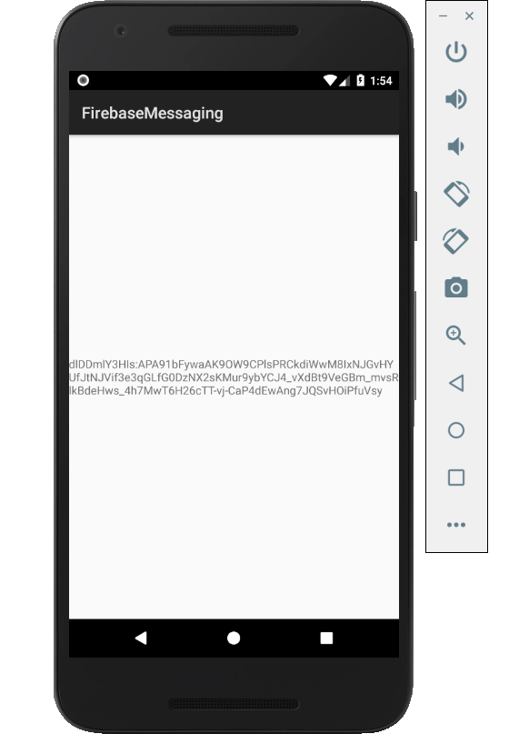

Figure 1. By Android Studio - https://developer.android.com/studio/, CC BY-SA 4.0, https://commons.wikimedia.org/w/index.php?curid=74094999

### 3.2.2 Image/firmware

Status

/1 Hardware present?

/1 Memo by student B + How did you make your Image/firmware? (500 words)

/1 Code can be run via serial or remote desktop

/1 Wireless connectivity

/1 Sensor/effector code on repository

Each component of the smartwatch is designed with its own firmware with which displays a confirmation of working order by displaying an address with the command i2cdetect -y 1 with the exception of the raspberry pi zero, these sensor’s firmware were made with python and use libraries form various sites such as adafruit in this case the raspberry pi firmware was made with the circumstance of not have a separate monitor instead we used the a laptop and its hardware (keyboard, screen, drivers etc.) to begin we downloaded rasbian form the raspberry pi website, unzipped and organizes the files onto our pi to allow the pi to connect properly to the pi we downloaded a few services on the laptop those services are listed as follows:

#### Bonjour print services

#### Ethcer

#### 7zip

#### Notepad++

#### To set up these services we followed the instructions as follows:

#### Open "config.txt" file with Notepad++

#### Scroll down to the bottom

#### Type "dtoverlay=dwc2" in the last line and then add an extra line after that

#### Save and close the file

#### Open "cmdline.txt" file with Notepad++

#### Look for the section after "rootwait"

#### Type "modules-load=dwc2,g_ether" in this section

#### Save and close the file

#### Create a new file called "ssh"

#### Eject the MicroSD Card and place it on your Raspberry Pi

#### Next, we connected the Raspberry Pi using a MicroUSB cable connected to the port marked "USB", opened Putty and entered "[pi@raspberrypi.local](mailto:pi@raspberrypi.local)" in the IP address box. Using the credentials pass: "raspberry" we’re given access and began to connect to WIFI via the steps below:

#### Type "sudo nano /etc/wpa_supplicant/wpa_supplicant.conf" Press "Enter" then go to the bottom of the text editor.

#### Type in the following

**"network={**

**ssid="YOURNETWORKNAME"**

**psk="YOURNETWORKPASSWORD"**

**}"**

#### Press "Ctrl X"

#### Press "Y"

#### Press "Enter"

#### Type "sudo wpa_cli reconfigure"

The libraries necessary for this are located at <https://circuitpython.org/libraries> which we copied the following libraries out of the library bundle into your sd card:

* adafruit_tmp006.mpy
* adafruit_bus_device

Enabling i2c and SPi involved typing the following commands:

* sudo apt-get install python-smbus
* sudo apt-get install i2c-tools

once done you can test your i2c address by typing "sudo i2cdetect -y 0". Lastly, we used the code to detect actual temperature heartbeat and steps with, each sensor varying in design.

TMP006- Temperature sensor:

*//# Define a function to convert celsius to fahrenheit. def c_to_f(c): return c * 9.0 / 5.0 + 32.0*

*//# Create library object using our Bus I2C port i2c = busio.I2C(board.SCL, board.SDA) sensor = adafruit_tmp006.TMP006(i2c)*

*//# Initialize communication with the sensor, using the default 16 samples per conversion. //# This is the best accuracy but a little slower at reacting to changes. //# The first sample will be meaningless while True: obj_temp = sensor.temperature print('Object temperature: {0:0.3F}*C / {1:0.3F}*F'.format(obj_temp, c_to_f(obj_temp))) time.sleep(5.0)*

ADXL345- Accelerometer:

MCP3008- Heartrate sensor:

### 3.2.3 Breadboard/Independent PCBs

Status

/1 Hardware present?

/1 Memo by student C + How did you make your hardware? (500 words)

/1 Sensor/effector 1 functional

/1 Sensor/effector 2 functional

/1 Sensor/effector 3 functional

The initial schematic design, Figure 2, based on datasheets (Bosch Sensortec, 2019) led to a breadboard layout Figure 3 that was realized Figure 4.

How did you build your Prototype: Breadboard?

Then a PCB was designed, Figure 5, and populated (Figure 6). Bill of Materials, Case, Time commitment. Testing. Progress.

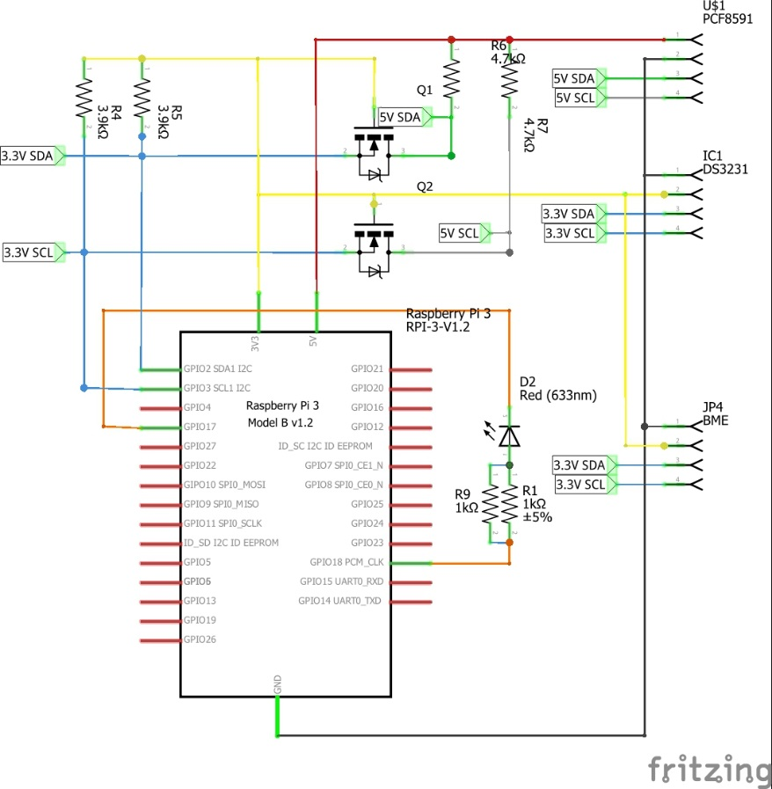

Figure 2. Initial schematic. This work is a derivative of "http://fritzing.org/parts/" by Fritzing, used under CC:BY-SA 3.0.

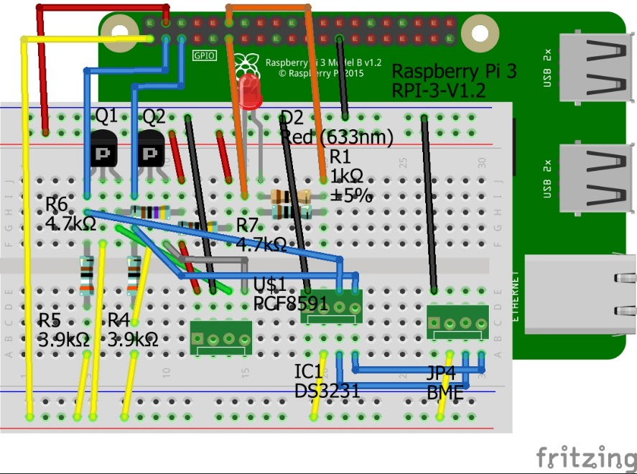

Figure 3. This work is a derivative of "http://fritzing.org/parts/" by Fritzing, used under CC:BY-SA 3.0.

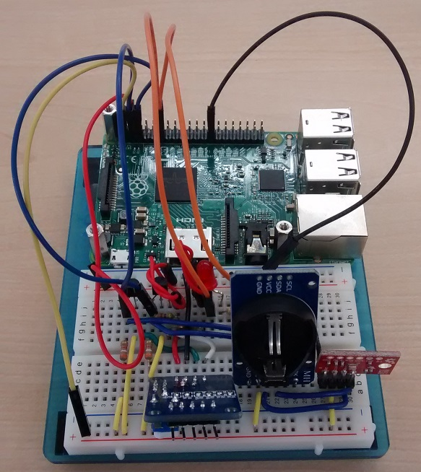

Figure 4. Breadboard prototype.

### 3.2.4 Printed Circuit Board

Demo

/1 Hardware present?

/1 PCB Complete and correct

/1 PCB Soldered wire visible but trim, no holes or vacancies

/1 PCB Tested with multimeter

/1 PCB Powered up

How did you build your Prototype: PCB?

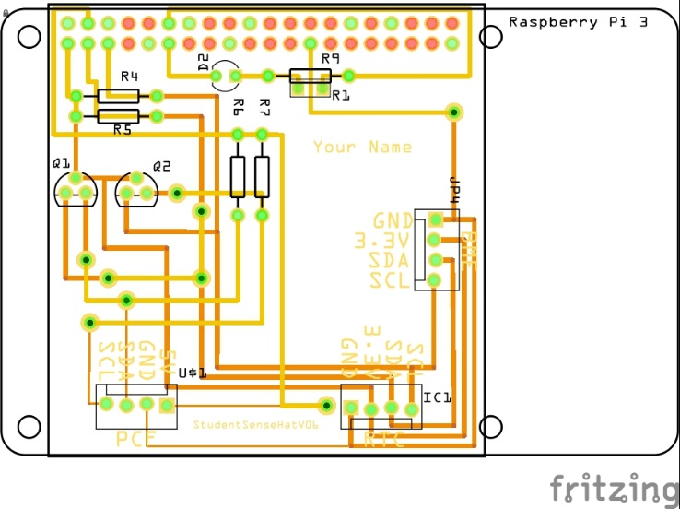

Figure 5. PCB design This work is a derivative of "http://fritzing.org/parts/" by Fritzing, used under CC:BY-SA 3.0.

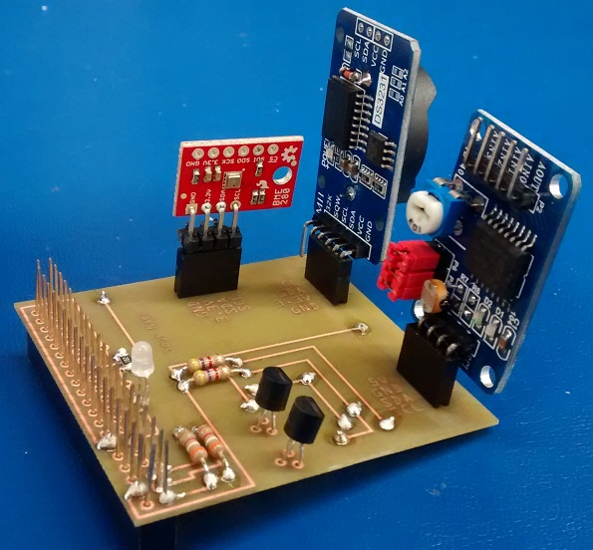

Figure 6. Humber Sense Hat Prototype PCB.

### 3.2.5 Enclosure

Demo

/1 Hardware present?

/1 Case encloses development platform and custom PCB.

/1 Appropriate parts securely attached.

/1 Appropriate parts accessible.

/1 Design file in repository, photo in report.

How did you build your Prototype: Case?

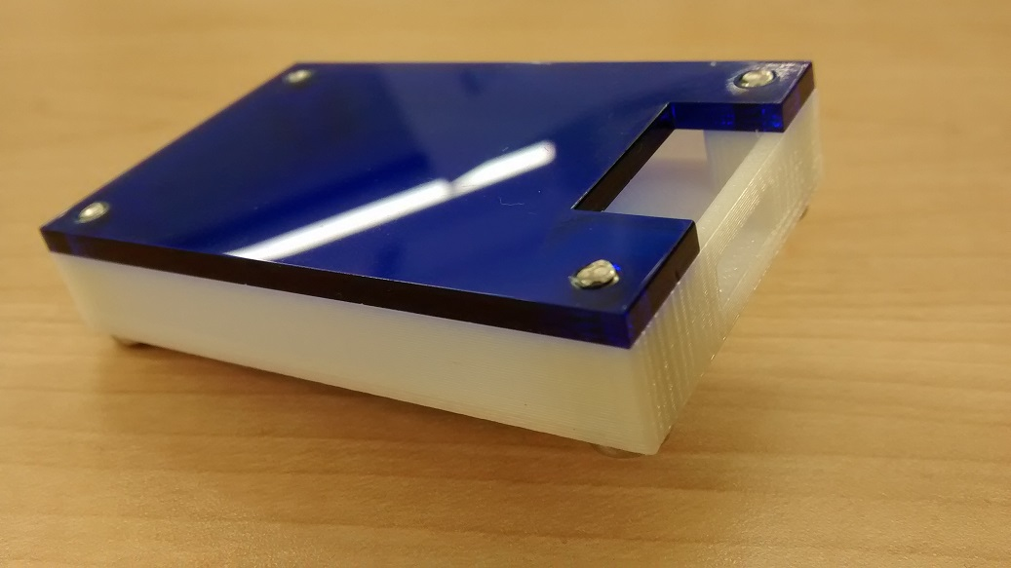

Figure . Example enclosure.

## 3.3 Integration

Demo

/1 Hardware present?

/1 Data sent by hardware

/1 Data retrieved by mobile application

/1 Action initiated by mobile application

/1 Action recieved by hardware

Report

/1 Enterprise wireless connectivity (250)

/1 Database configuration (250 words)

/1 Security considerations (500 words)

/1 Unit testing (900 words)

/1 Production testing (100 words)

### 3.3.1 Enterprise Wireless Connectivity

How did you make a Database accessible by both your Prototype and Mobile Application?

### 3.3.2 Database Configuration

### 3.3.3 Security

### 3.3.4 Testing

Unit testing and Production testing.

# 4.0 Results and Discussions

Is your prototype perfect? What did you learn?

# 5.0 Conclusions

If you were making 1000 of these.

Report

/1 Hardware present?

/1 Checklist truthful

/1 Valid Comments

/1 Results and Discussion (500 words)

/1 Conclusion

# 6.0 References

Bosch Sensortec. (2019, July). *BME680 - Datasheet.* Retrieved from Robert Bosch GmbH: https://ae-bst.resource.bosch.com/media/_tech/media/datasheets/BST-BME680-DS001.pdf

Kinsella, J. (2019). Five trends predicted for the cloud industry in 2019. *Software World*, 50(1), 11.

Media, O. (2019). *O'Reilly artificial intelligence conference 2019 - San Jose, California.* California: O'Reilly Media, Inc.

OACETT. (2017, March). *I need to Complete a Technology Report*. Retrieved from The Ontario Association of Certified Engineering Technicians and Technologists: https://www.oacett.org/Membership/Technology-Report-and-Seminar

Robuck, M. (2018, 11). AWS goes deep and wide with machine learning services and capabilities. *Fierceinstaller*.

# 7.0 Appendix

## 7.1 Firmware code

Demo

/1 Hardware present?

/3 Code runs concurrently for all sensors/effectors

/1 Project repository contains integrated code

Status

/1 Memo including updates

/1 Financial update

/1 Progress update

/1 Modified Code Files in Appendix

/1 Link to Complete Code in Repository

## 7.2 Application code

Demo

/1 Hardware present?

/1 Memo by student A

/1 Login activity

/1 Data visualization activity

/1 Action control activity

Report

/1 Login activity

/1 Data visualization activity

/1 Action control activity

/1 Modified Code Files in Appendix

/1 Link to Complete Code in Repository